Subject: Programming with Java
ASSIGNMENT No : 14
TITLE :Write a Java program to demonstrate exception handling using try and catch blocks, nested and multiple try-catch blocks.

Name: Avdhoot Mohite Class: CSE A3
PRN: 25070122056 Batch:25-29

Problem Statement
Write a Java program to demonstrate exception handling using try and catch blocks, nested and multiple try-catch blocks.
Learning Objectives
To handle runtime exceptions using try-catch, nested try, and multiple catch blocks.
Theory
Exception handling prevents abnormal termination of programs due to runtime errors. The try block contains code that may generate exceptions, while catch blocks handle specific exceptions. Nested and multiple try-catch structures allow complex error management. Exception handling improves software reliability and user experience by gracefully managing unexpected situations.
Outcome
After completing this experiment, we learned how to handle runtime exceptions in Java using try-catch blocks, nested try-catch, and multiple catch blocks. We understood how different exceptions can be handled appropriately to prevent abnormal program termination and improve the reliability and robustness of Java applications.
Conclusion
The experiment successfully demonstrated exception handling using try-catch, nested try-catch, and multiple catch blocks in Java. These techniques help identify and handle different runtime errors efficiently, ensuring smooth program execution, improving software reliability, and providing a better user experience.

Exercise
1.Create an ATM program handling invalid withdrawal amount using try-catch
Code:
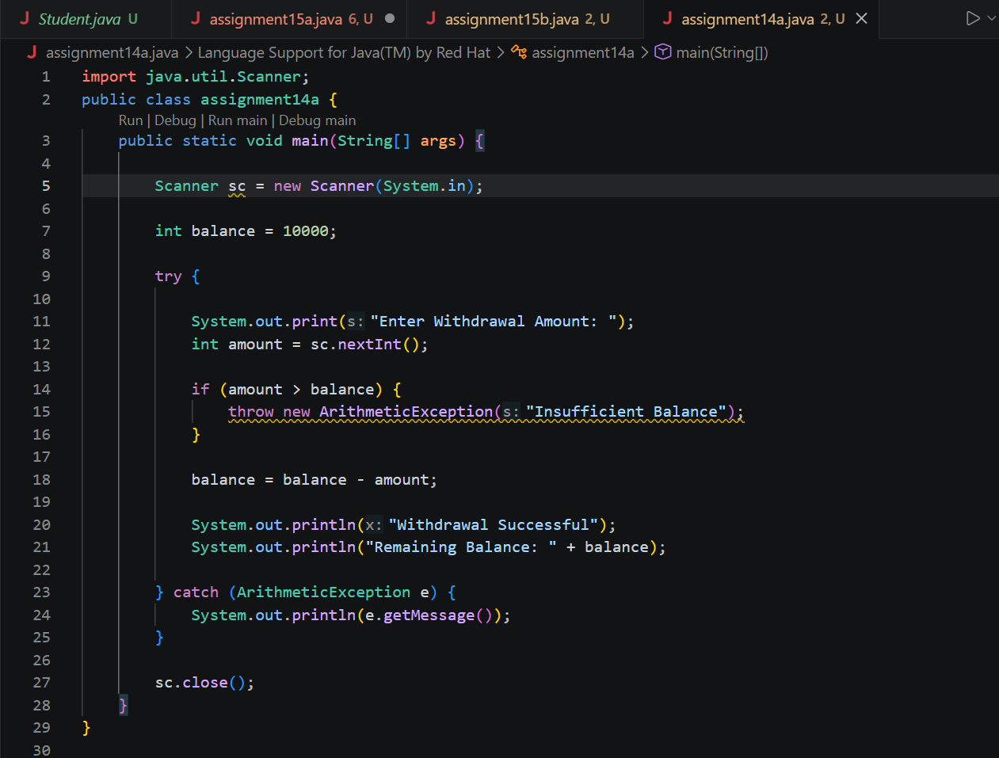

Output:
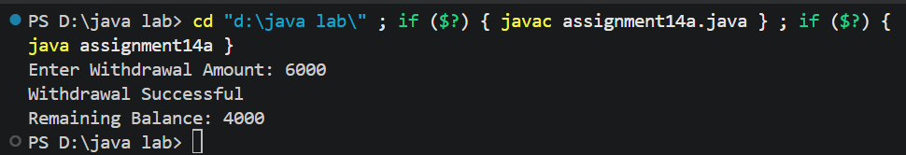

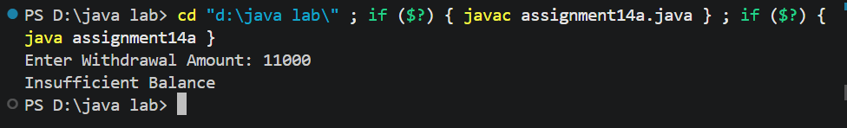

2.Create an Online Shopping program that handles an invalid product quantity entered by the user using a try-catch block. Display an appropriate error message if the quantity is less than or equal to zero.
Code:
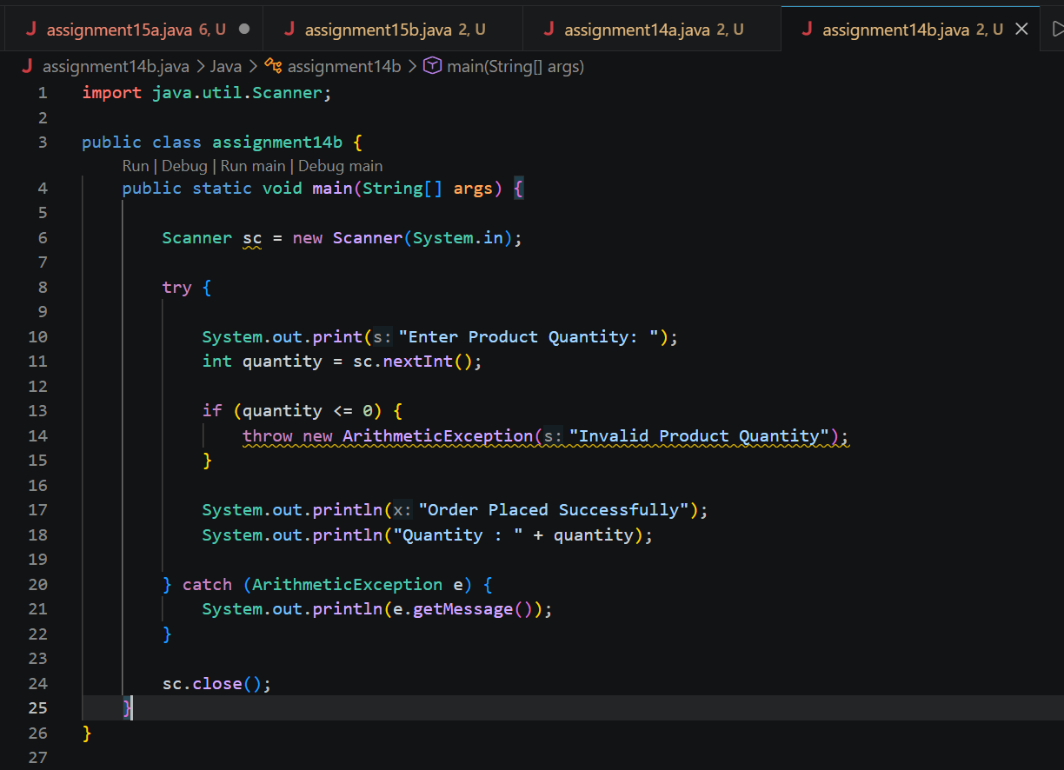
Output:
